FATIMA JINNAH WOMEN UNIVERSITY


Submitted to:
Inst: Adeel Khalid
Submitted by:
Faryal Asif-BCS -(030)
Hamna Arshad-BCS -(036)
Warda Nayab-BCS - (091)
Hamna Qandeel-BCS -(038)
Hamna Noor-BCS-(037)
Program & Session:
2023-27-BCS-II-B
Course Title:
Database Management System
LAB REPORT
Introduction:
A Library Management System (LMS) is a software application designed to manage and maintain the records of a library. It helps in automating various functions such as tracking books, managing member details, issuing and returning books, and maintaining inventory. This report outlines the design and implementation of a simple Library Management System using a Database Management System (DBMS).
Objectives:
• To design a database for managing library operations.
• To implement basic CRUD (Create, Read, Update, Delete) operations.
• To ensure data integrity and consistency.
Database Design:
- Publisher
- Book
- Member
- Borrowing
Entity-Relationship (ER) Diagram:
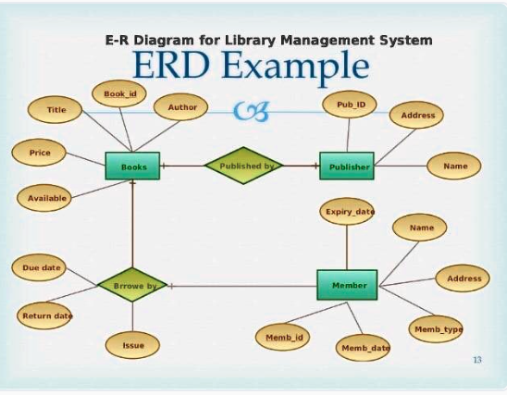
SQL Queries:
- Creating Tables
- Inserting Data
- Retrieving Data
- Updating Data
- Deleting Data

Conclusion:
This simple Library Management System demonstrates the basic functionality required to manage a library's operations using a DBMS. By creating and managing tables for books, members, and loans, we can efficiently handle the data and ensure smooth library operations. The implementation of SQL queries for CRUD operations ensures data integrity and consistency, making the system reliable and easy to use.

